

**S. B. JAIN INSTITUTE OF TECHNOLOGY, MANAGEMENT & RESEARCH, NAGPUR.**

**Practical No. 2**

**Aim:** Understand the use of table and create a Study Time Table using HTML tags.

**Name of Student: Sunil Kambale**

**Roll No.: AD22038**

**Semester/Year: 2nd** /1st

**Academic Session:**

**Date of Performance:**

**Date of Submission:**

**OBJECTIVE/EXPECTED LEARNING OUTCOME:**

The objectives and expected learning outcome of this practical are:

* To apply the knowledge of basic HTML tags.
* To apply the knowledge of table tags
* Able to design the Time Table

**HARDWARE AND SOFTWARE REQUIREMENT**:

**Hardware Requirement**

* + - 1.6 GHz or faster processor
    - .RAM: 1 GB
    - Hard Disk Drive: > 80 GB

**Software Requirement**

* + - Operating System – Windows 2007,2010.
    - Editor – Visual Studio Code /SublimeText.

**THEORY:**

**Table Tag**

* + - The HTML tables allow web authors to arrange data like text, images, links, other tables, etc. into rows and columns of cells.
    - The HTML tables are created using the &<table> tag in which the &<tr>tag is used to create table rows and <td>tag is used to create data cells. The elements under &<td> are regular and left aligned by default. **Rowspan:** It is used to merge the rows of table **Colspan:** It is used to merge the columns.

**Cellspacing:** Cellspacing Attribute is used to specify the space between the cells.

The cellspacing attribute is set in terms of pixels.

**Cellpadding:** The cell padding attribute places spacing around data within each cell.

The cell spacing attribute places space around each cell in the table.

**CODE:** 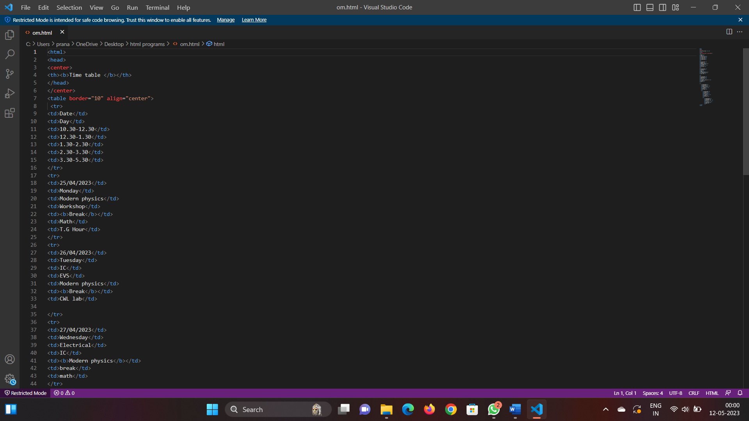

**OUTPUT SCREENSHOT:**

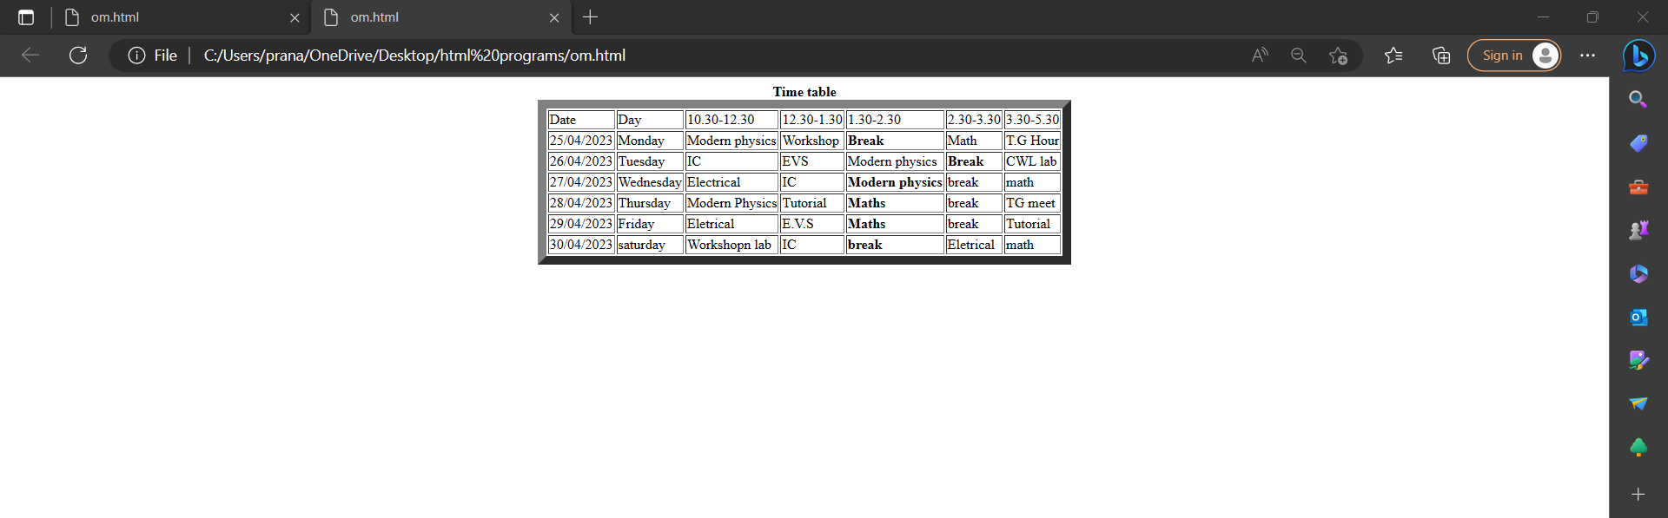

**CONCLUSION:**

**DISCUSSION QUESTIONS:**

* 1. What is the use of table?
  2. How do you use cellpadding and cellspacing?
  3. Which tag is used for heading in table?
  4. Which tag is used to add columns in the tables?
  5. <td> tag, td stands for?

**REFERENCE:**

* + - * [*https://www.w3schools.com/TAgs/default.asp*](https://www.w3schools.com/TAgs/default.asp)
      * [*https://simplycoding.in/html-tables-question-ba nk/*](https://simplycoding.in/html-tables-question-bank/)
      * [*https://www.tutorialspoint.com/html/html_lists. html*](https://www.tutorialspoint.com/html/html_lists.html)
      * [*https://www.tutorialspoint.com/html/html_table s.htm*](https://www.tutorialspoint.com/html/html_tables.htm)